HOMEWORK ASSIGNMENT 3

5) Problem 14.2-2 on Page 347

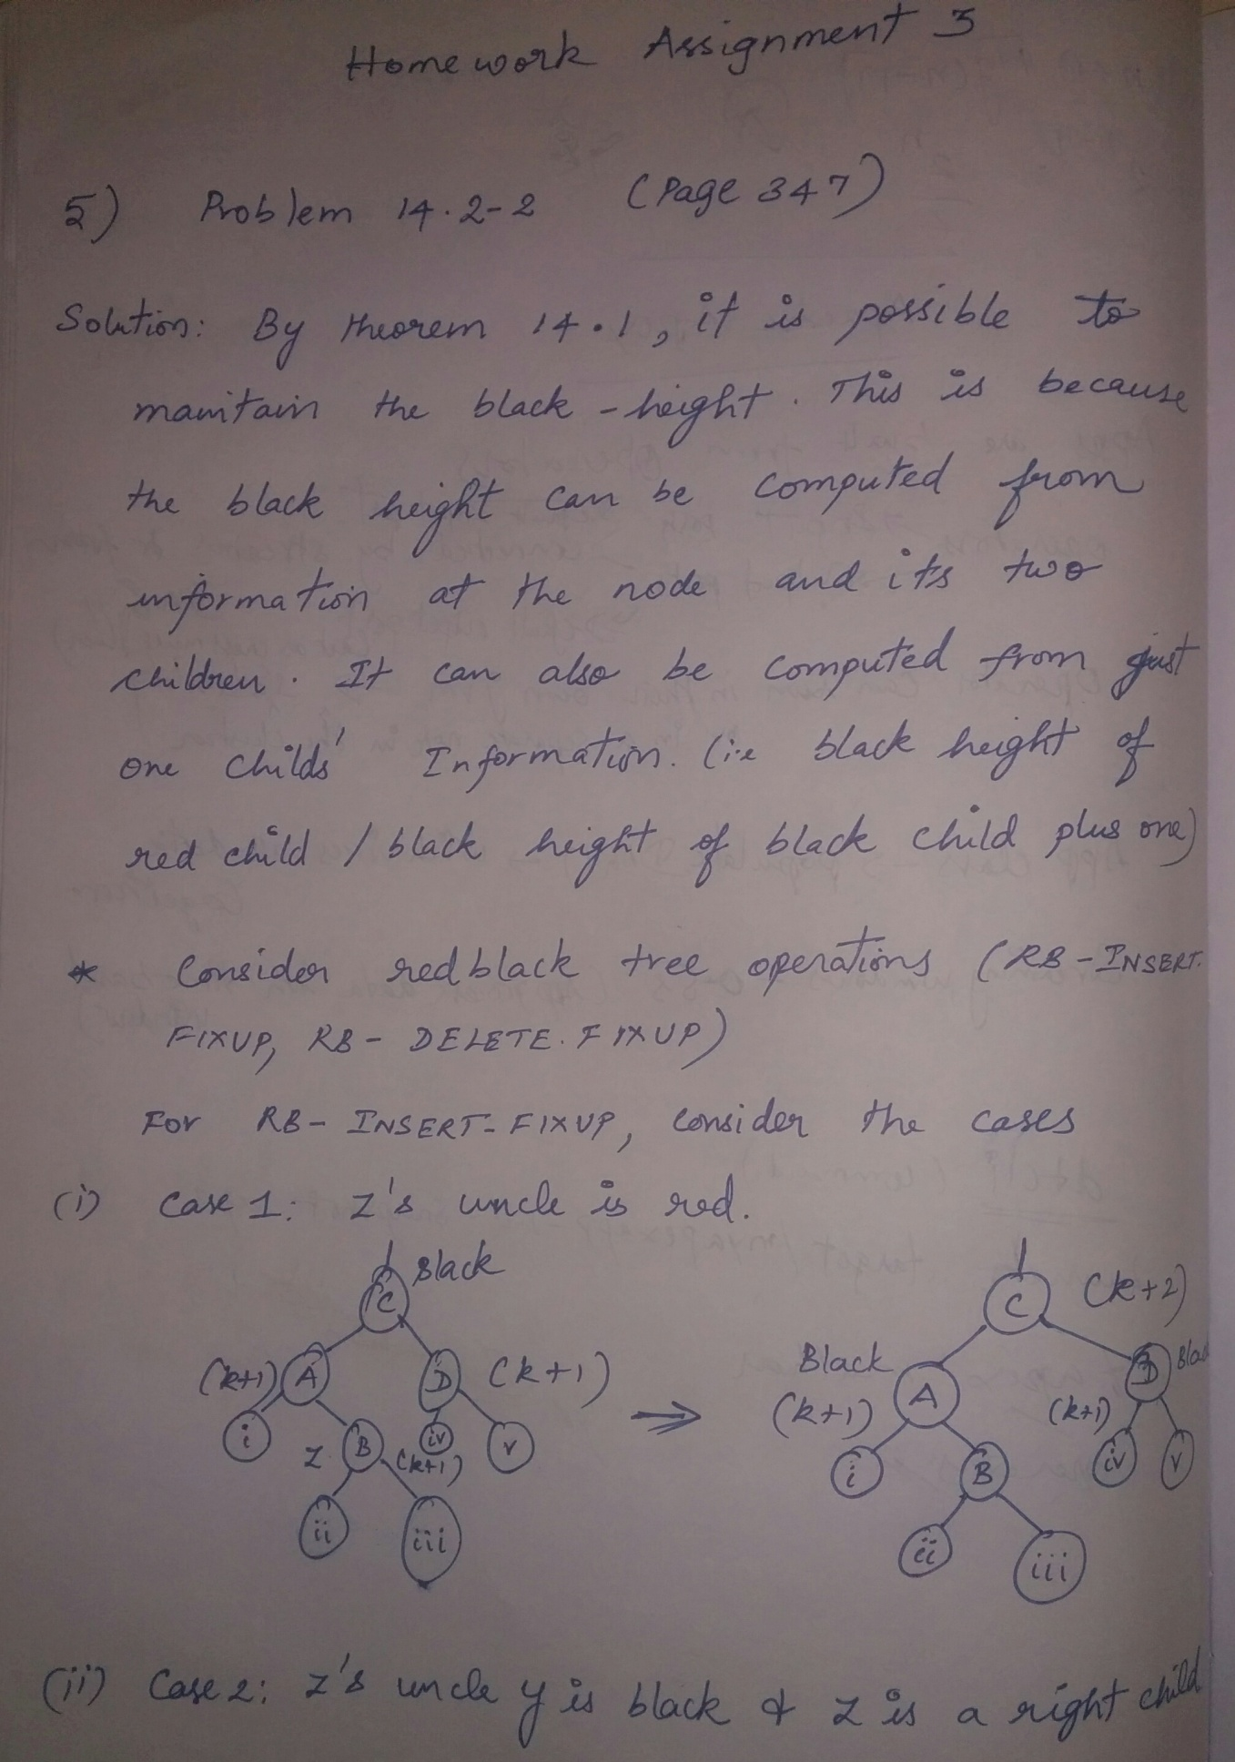

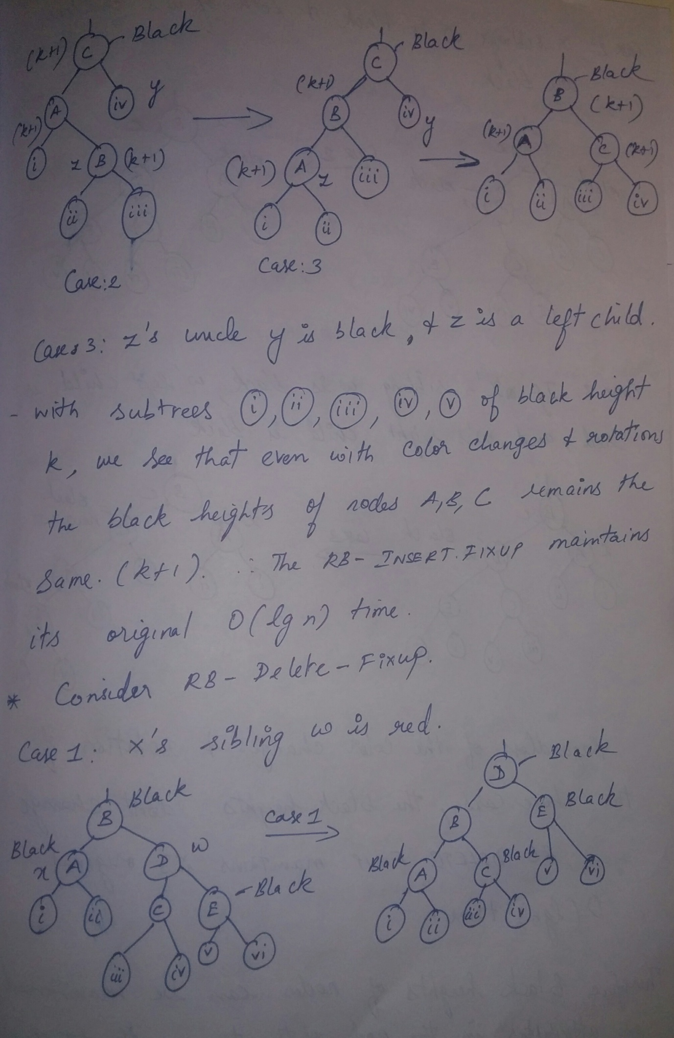

5th Continuation

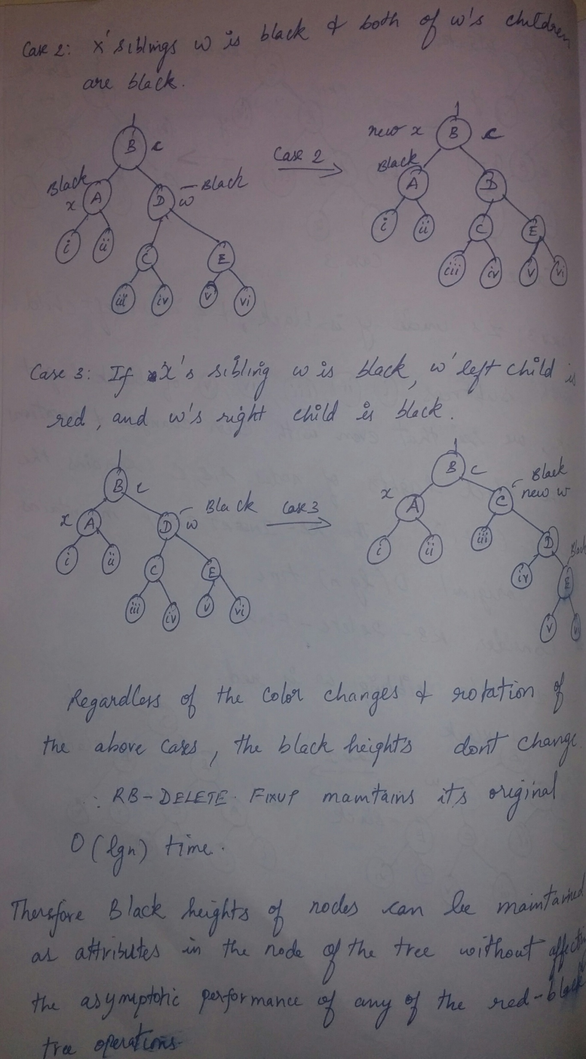

5th problem continuation and 4th problem 13.4-6 on page 330

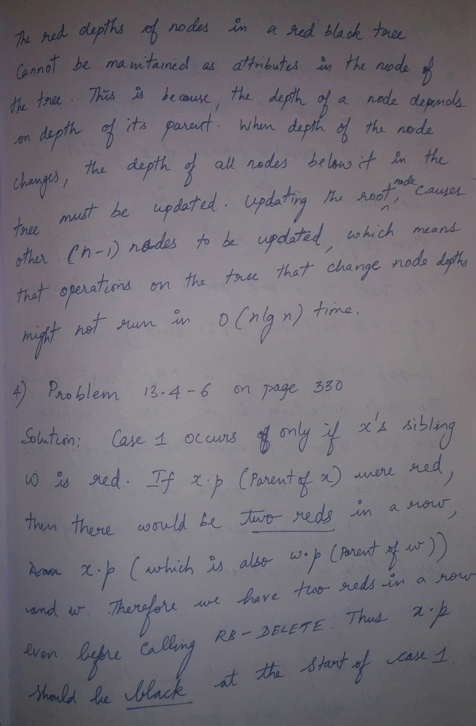

3rd Problem 13.3-4 on Page 322 and 2nd Problem 13.1-5 on Page 312

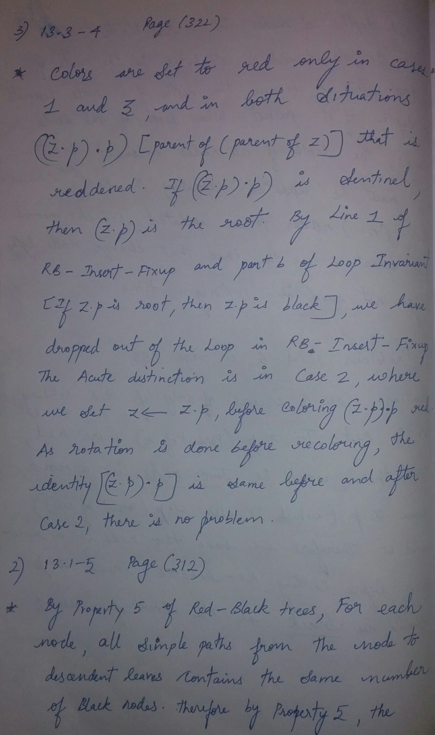

2nd Problem continuation and 1st Problem 12.3-2 on Page 299

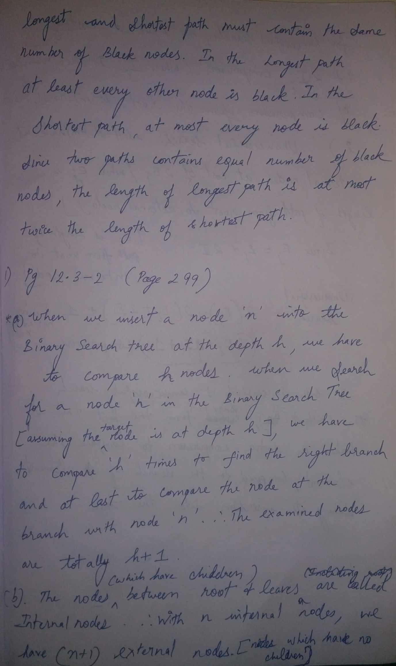

1st Problem continuation.

